**TIENG ANH 7 ( WEEK : 1 –6/2/2021)**

**Period 1 : Unit 10 B 2 B3**

**B 2 Listen and answer.**

*(Nghe và trả lời)*

**Questions.**

*(Câu hỏi)*

a) What is Dr Lai's job?

b) What clothes does Dr Lai wear to work?

c) How to most children feel when they come to see Dr Lai?

d) How does Dr Lai help these children?

**Keys:**

a) Doctor Lai is a dentist at ỌuangTrung school.

b) She wears a uniform to work.

c) Most children feel scared when they come to see Dr. Lai.

d) She gives the children some advice, tells them how to look after their teeth and reminds them to clean their teeth regularly.

**Tapesript:**

Dr. Lai is a dentist at Quang Trung school.

She looks after all the students’ teeth.

Dr Lai’s office is clean and so is her uniform.

She always washes her hands after each child leaves.

Many children are scared when they come to see Dr Lai, but she is a kind woman, she explains what will happen so they are not afraid.

Dr Lai gives the children advice.

She tell them how to look after their teeth.

She reminds them to clean their teeth regularly and eat sensibly.

**3. Listen and read.** (Nghe và đọc)

Minh is sitting in Dr Lai’s surgery. Dr Lai is checking his teeth.

Dr Lai is kind. She smiles at Minh and says, ‘Don't worry. MinhẾ You have one small cavity, but it isn't serious. Your other teeth are fine.'

Minh is very happy. Dr Lai fills the cavity in Minh's tooth. She finishes in less than 10 minutes. Minh is very pleased. Then Dr Lai sits down and talks to Minh again.

“How often do you brush your teeth, Minh?" she asks. Minh looks worried again.

'Oh, I ... Well, sometimes I forget to brush my teeth.’

‘Try not to forget', Dr Lai says.

‘Brushing your teeth is very important. Clean teeth are healthy teeth!’

**Now complete the story**

(Bây giờ điền vào câu chuyện)

Minh is very **_______** and Dr. Lai notices this. She **_______** at Minh and tells not to worry. She explains one of his teeth has a **_______**. He has to **_______** them regulariy. After Dr. Lai fils his tooth. Minh leaves. He is very **_______.**

**Keys**

Minh is very **nervous** and Dr. Lai notices this. She **smiles** at Minh and tells not to worry. She explains one of his teeth has a **cavity**. He has to **clean brush** them regulariy. After Dr. Lai fils his tooth. Minh leaves. He is very **pleased.**

**Period 2: Unit 10 : B4; B5**

**4. Ask and answer questions with a partner.**

**Use the words to help you.**

*(Hỏi và đáp với bạn cùng học. Dùng từ để giúp em)*

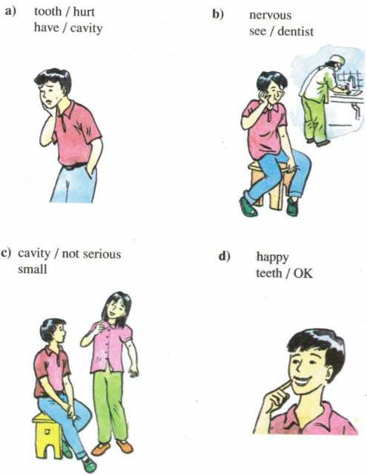

**Hướng dẫn**

a) Minh's tooth hurts.

Why?

Because he has a cavity.

b) He looks nervous?

Why?

Because he is seeing a dentist.

c) The cavity isn't serious.

Why?

Because it’s very small.

d) Minh looks happy.

Why?

Because his teeth are ok now.

**B5.**

**5. Write. Complete this poster with a partner.**

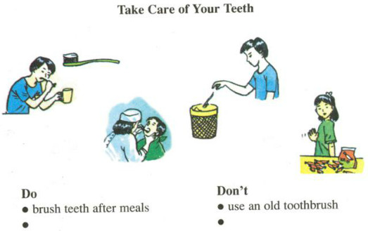

|  |  |
| --- | --- |
| **Take care of your teeth** | |
| **Do** | **Don’t** |
| - Brush teeth after meals  - Use a good toothbrush  - Use good toothpaste  - Go to a dentist when having a toothache | - Use an old toothbrush  - Eat lots of candy and sweets |

**Period 3 : Unit 11 A1**

**A. A check-up** (Phần 1-3 trang 107-109 SGK Tiếng Anh 7)

**1. Listen. Then practice with a partner.**

**New words :**

**have a medical check up (v)**

**fill in the medical record(v)**

**take someone’s temperature (v) đo nhiệt độ**

**degree Celsius ( độ c)**

**normal (a)**

**measure (v)**

**high (a) 🡪 height (n)**

**get on the scale (v)**

**weigh(v) 🡪 weight(n)**